SHAHA MOHIDEEN
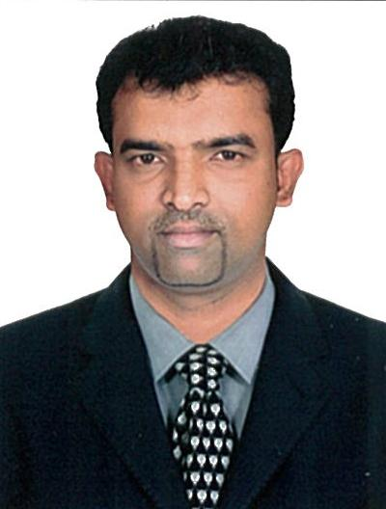
Date of Birth: 27th March 1981 (38 Years)
Email id: shaham1981@gmail.com

Mobile No.: +91 81242 01972
Present Address:
No:1, Raisha Hut, Lemaire Street, Karaikal - 609602
Nationality – Indian

Career Objective

To obtain a challenging and multi-tasking position in a dynamic organization that capitalizes on my strong experience, communication and interpersonal skills to achieve company objectives.

Education Background

- June 2003 – May 2006 Master of Computer Application ( First Class)
TBML College, Chennai India

- June 2001 - May 2003 Bachelor of Computer Application ( First Class)
TBML College, Chennai India

- June 1999 - May 2001 Hr. Sec School
St. Mary’s Hr. Sec School
Karaikal, India

- June 1998 – May 1999 Sec School Leaving Certificate (SSLC)
St. Antony’s Hr. Sec School
Nagapattinam, India
Key Achievement

- Transportation Management System
Develop the main page for the transport management system. In this project I managed to successfully develop front end using J2EE (Java2 Enterprise Edition) and the back end using SQL database.

- Successfully completed project for leading Emirates bank.

Working Experiences:

- December 2016 – July 2018 Worked as a Computer Science teacher
Bright Academy - CBSE Curriculum- Karaikal
Preparing daily and long-term lesson plans according to curriculum guidelines

- April 2012 – August 2016 IBM ITS Administrator
Gulf Business Machine Co, Dubai.
(Sole Distributor for IBM for Emirates)
- Ensure there are sufficient inventory spares for IBM and Cisco products)

- August 2011 – January 2012 Facility Management coordinator
Serveu llc Dubai.
- Prepare sales and costing for engineering solutions.
- Major clients include some of the leading bank in Emirates.

- August 2008 – June 2011 Lecturer in Computer Science Department
EGS Pillay Arts and Science College
Nagapattinam
- contact/teaching time with students
- writing research proposals, papers and other publications
- reading academic journals
- supervising PhD students and research staff
- checking and assessing students work
Skills and strength:

- Self-motivated.
- Self determined and ambitious.
- Good negotiation skill.
- Eager to learn and progress.
- Team player.
Computer programming skills:

- Competent in Operating Systems: Windows9X, Windows2000, Windows ME, Windows XP and Vista.
- Competent office packages: MS Word, Excel, access. PowerPoint, and MS Outlook Express.
- Competent in troubleshooting computer program.
Languages known:

- Fluent in English, Tamil, Kannada, Hindi, Malayalam
- Moderate in Arabic

